**MODULE 5**

**PROBABILITY DISTRIBUTIONS AND**

**PROBABILITY DISTRIBUTIONS**

**Probability:**

The word 'Probability' means the chance of occurring of a particular event. It is generally possible to predict the future of an event quantitatively with a certain probability of being correct. The probability is used in such cases where the outcome of the trial is uncertain.

Probability Definition:

The probability of happening of an event A, denoted by P(A), is defined as

Probability

Thus, if an event can happen in m ways and fails to occur in n ways and m+n ways is equally likely to occur then the probability of happening of the event A is given by

Probability

And the probability of non-happening of A is

Probability

**Note:**

1. The probability of an event which is certain to occur is one.
2. The probability of an event which is impossible to zero.
3. If the probability of happening of an event P(A) and that of not happening is P(A), then  
               P(A)+ P(A) = 1, 0 ≤ P(A) ≤ 1,0≤ P(A)≤1.

Important Terms related to Probability:

**1. Trial and Event:** The performance of an experiment is called a trial, and the set of its outcomes is termed an event.

**Example:** Tossing a coin and getting head is a trial. Then the event is {HT, TH, HH}

**2. Random Experiment:** It is an experiment in which all the possible outcomes of the experiment are known in advance. But the exact outcomes of any specific performance are not known in advance.

**Example:**

1. Tossing a Coin
2. Rolling a die
3. Drawing a card from a pack of 52 cards.
4. Drawing a ball from a bag.

**3. Outcome:** The result of a random experiment is called an Outcome.

**Example:** 1. Tossing a coin is an experiment and getting head is called an outcome.  
                 2. Rolling a die and getting 6 is an outcome.

**4. Sample Space:** The set of all possible outcomes of an experiment is called sample space and is denoted by S.

**Example:** When a die is thrown, sample space is S = {1, 2, 3, 4, 5, 6}  
                  It consists of six outcomes 1, 2, 3, 4, 5, 6

Note1: If a die is rolled n times the total number of outcomes will be 6n.

Note2: If 1 die rolled n times then n die rolled 1 time.

**5. Complement of Event:** The set of all outcomes which are in sample space but not an event is called the complement of an event.

**6. Impossible Events:** An event which will never be happened.

**Example1:** Tossing double-headed coins and getting tails in an impossible event.

**Example2:** Rolling a die and getting number > 10 in an impossible outcome.  
                   P (impossible outcome) =0

**7. Sure Outcome/Certain Outcome:** An Outcome which will definitely be happen

**Example1:** Tossing double-headed coins and getting heads only.

**Example2:** Rolling a die and getting number < 6  
                   P (sure outcome) = 1  
                   {1, 2, 3, 4, 5 6} is called sure event  
                   P (sure outcome) = 1

**8. Possible Outcome:** An outcome which is possible to occur is called Possible Outcome.

**Example1:** Tossing a fair coin and getting a head on it.

**Example2:** Rolling a die and getting an odd number.

**9. Equally Likely Events:** Events are said to be equally likely if one of them cannot be expected to occur in preference to others. In other words, it means each outcome is as likely to occur as any other outcome.

**Example:** When a die is thrown, all the six faces, i.e., 1, 2, 3, 4, 5 and 6 are equally likely to occur.

**10. Mutually Exclusive or Disjoint Events:** Events are called mutually exclusive if they cannot occur simultaneously.

**Example:** Suppose a card is drawn from a pack of cards, then the events getting a jack and getting a king are mutually exclusive because they cannot occur simultaneously.

**11. Exhaustive Events:** The total number of all possible outcomes of an experiment is called exhaustive events.

**Example:** In the tossing of a coin, either head or tail may turn up. Therefore, there are two possible outcomes. Hence, there are two exhaustive events in tossing a coin.

**12. Independent Events:** Events A and B are said to be independent if the occurrence of any one event does not affect the occurrence of any other event.  
                       P (A ∩ B) = P (A) P (B).

**Example:** A coin is tossed thrice, and all 8 outcomes are equally likely  
                 A: "The first throw results in heads."  
                 B: "The last throw results in Tails."

Prove that event A and B are independent.

**Solution:**

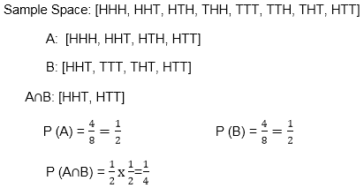

**13. Dependent Event:** Events are said to be dependent if occurrence of one affect the occurrence of other events.

**PROBABILITY DISTRIBUTIONS**

This is fundamental concepts in probability theory and statistics.

They describe how the probabilities of different outcomes or events are distributed across a set of possible values.

Probability distributions are used to model and analyze a wide range of phenomena in various fields, including science, engineering, economics, finance, and more. Here are some common probability distributions:

1. **Discrete Probability Distributions:**
   * **Bernoulli Distribution:** A binary distribution with two possible outcomes, typically denoted as success (1) and failure (0), with a single parameter p representing the probability of success.
   * **Binomial Distribution:** Models the number of successes in a fixed number of independent Bernoulli trials. It has two parameters: n (number of trials) and p (probability of success).
   * **Poisson Distribution:** Describes the number of events occurring in a fixed interval of time or space. It has one parameter, λ (lambda), representing the average rate of occurrence.
2. **Continuous Probability Distributions:**
   * **Normal (Gaussian) Distribution:** Often referred to as the bell curve, it is characterized by its mean (μ) and standard deviation (σ). It is used to model a wide range of natural phenomena.
   * **Uniform Distribution:** All values within a given interval are equally likely. It is characterized by two parameters: a (minimum) and b (maximum).
   * **Exponential Distribution:** Models the time between events in a Poisson process. It has one parameter, λ (lambda), representing the rate parameter.
   * **Gamma Distribution:** A generalization of the exponential distribution, it has two parameters, α (alpha) and β (beta).
3. **Multinomial Distribution:** Extends the binomial distribution to scenarios where there are more than two possible outcomes. It is characterized by the probabilities of each outcome.
4. **Hypergeometric Distribution:** Models the probability of drawing a specific number of successes from a finite population without replacement.
5. **Geometric Distribution:** Models the number of trials needed to achieve the first success in a sequence of independent Bernoulli trials.
6. **Logistic Distribution:** Often used to describe growth processes and has applications in logistic regression.
7. **Weibull Distribution:** Used to model time-to-failure data and reliability analysis. It has parameters that affect the shape of the distribution.
8. **Beta Distribution:** Defined on the interval [0, 1] and is commonly used to model probabilities or proportions.
9. **Cauchy Distribution:** Has heavy tails and lacks finite moments, making it useful in some specialized statistical applications.

**R NORMAL DISTRIBUTION**

The normal distribution, also known as the Gaussian distribution, is one of the most important and widely used probability distributions in statistics. It is characterized by its bell-shaped curve and is often used to model the distribution of continuous data in various fields such as natural sciences, social sciences, engineering, and finance.

The probability density function (PDF) of the normal distribution is defined by two parameters:

1. **Mean (μ):** The mean, or average, represents the center of the distribution and determines where the peak of the curve is located.
2. **Standard Deviation (σ):** The standard deviation controls the spread or dispersion of the data. A larger σ results in a wider distribution, while a smaller σ results in a narrower distribution.

The probability density function (PDF) of the normal distribution is given by the formula:

f (*x*)=*σ*2*π*​1​*e*−2*σ*2(*x*−*μ*)2​

Where:

* *f*(*x*) is the probability density at a specific value *x*.
* *μ* is the mean of the distribution.
* *σ* is the standard deviation of the distribution.
* *e* is the base of the natural logarithm (approximately 2.71828).
* *π* is the mathematical constant pi (approximately 3.14159).

Key properties of the normal distribution include:

1. **Symmetry:** The normal distribution is symmetric around its mean (*μ*), which means that the probability of observing values to the left and right of the mean are equal.
2. **Bell-shaped Curve:** The normal distribution has a single peak at the mean, and the shape of the curve is bell-shaped, with tails that extend infinitely in both directions.
3. **68-95-99.7 Rule:** In a normal distribution, approximately 68% of the data falls within one standard deviation of the mean, approximately 95% falls within two standard deviations, and about 99.7% falls within three standard deviations.
4. **Central Limit Theorem:** One of the most important properties of the normal distribution is that the sampling distribution of the sample mean from a population with any underlying distribution will tend to follow a normal distribution as the sample size increases.

The normal distribution is a fundamental concept in statistical analysis and hypothesis testing. Many statistical methods and tests assume that the data follow a normal distribution, or they rely on the properties of the normal distribution for inference. When working with real-world data, it's common to use statistical software or calculators to compute probabilities and perform statistical analysis involving the normal distribution.

In random collections of data from independent sources, it is commonly seen that the distribution of data is normal. It means that if we plot a graph with the value of the variable in the horizontal axis and counting the values in the vertical axis, then we get a bell shape curve. The curve center represents the mean of the data set. In the graph, fifty percent of the value is located to the left of the mean. And the other fifty percent to the right of the graph. This is referred to as the normal distribution.

R allows us to generate normal distribution by providing the following functions:

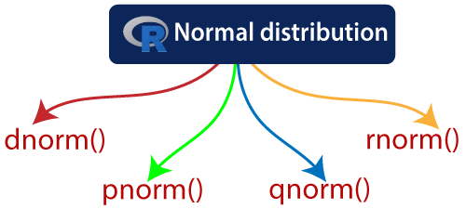

These function can have the following parameters:

|  |  |  |
| --- | --- | --- |
| **S.No** | **Parameter** | **Description** |
| 1. | x | It is a vector of numbers. |
| 2. | p | It is a vector of probabilities. |
| 3. | n | It is a vector of observations. |
| 4. | mean | It is the mean value of the sample data whose default value is zero. |
| 5. | sd | It is the standard deviation whose default value is 1. |

Let's start understanding how these functions are used with the help of the examples.

**dnorm():Density**

The dnorm() function of R calculates the height of the probability distribution at each point for a given mean and standard deviation. The probability density of the normal distribution is:

R Normal Distribution

**Example**

1. # Creating a sequence of numbers between -1 and 20 incrementing by 0.2.
2. x **<-** seq(-1, 20, by = .2)
3. # Choosing the mean as 2.0 and standard deviation as 0.5.
4. y **<-** dnorm(x, mean = 2.0, sd = 0.5)
5. # Giving a name to the chart file.
6. png(file = "dnorm.png")
7. #Plotting the graph
8. plot(x,y)
9. # Saving the file.
10. dev.off()

**Output:**

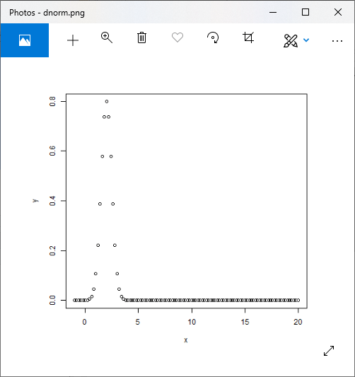

**pnorm():Direct Look-Up**

The dnorm() function is also known as "Cumulative Distribution Function". This function calculates the probability of a normally distributed random numbers, which is less than the value of a given number. The cumulative distribution is as follows:

f(x)=P(X≤x)

**Example**

1. # Creating a sequence of numbers between -1 and 20 incrementing by 0.2.
2. x **<-** seq(-1, 20, by = .1)
3. # Choosing the mean as 2.0 and standard deviation as 0.5.
4. y **<-** pnorm(x, mean = 2.0, sd = 0.5)
5. # Giving a name to the chart file.
6. png(file = "pnorm.png")
7. #Plotting the graph
8. plot(x,y)
9. # Saving the file.
10. dev.off()

**Output:**

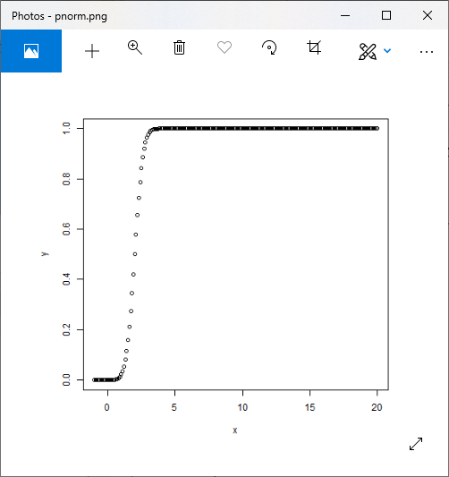

**qnorm():Inverse Look-Up**

The qnorm() function takes the probability value as an input and calculates a number whose cumulative value matches with the probability value. The cumulative distribution function and the inverse cumulative distribution function are related by

p=f(x)  
x=f-1 (p)

**Example**

1. # Creating a sequence of numbers between -1 and 20 incrementing by 0.2.
2. x **<-** seq(0, 1, by = .01)
3. # Choosing the mean as 2.0 and standard deviation as 0.5.
4. y **<-** qnorm(x, mean = 2.0, sd = 0.5)
5. # Giving a name to the chart file.
6. png(file = "qnorm.png")
7. #Plotting the graph
8. plot(y,x)
9. # Saving the file.
10. dev.off()

**Output:**

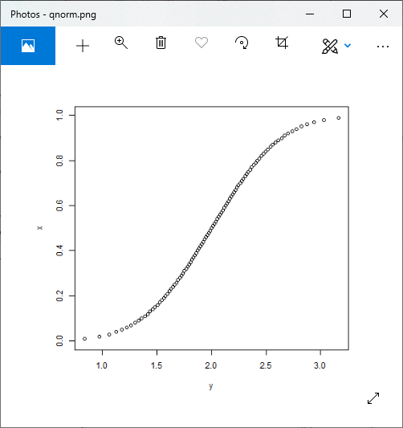

**rnorm():Random variates**

The rnorm() function is used for generating normally distributed random numbers. This function generates random numbers by taking the sample size as an input. Let's see an example in which we draw a histogram for showing the distribution of the generated numbers.

**Example**

1. # Creating a sequence of numbers between -1 and 20 incrementing by 0.2.
2. x **<-** rnorm(1500, mean=80,  sd=15 )
3. # Giving a name to the chart file.
4. png(file = "rnorm.png")
5. #Creating histogram
6. hist(x,probability =TRUE,col="red",border="black")
7. # Saving the file.
8. dev.off()

Output:

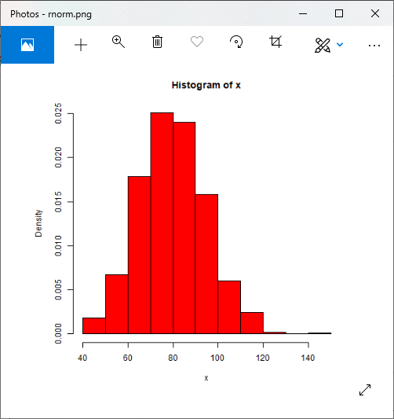

**BINOMIAL DISTRIBUTION**

The binomial distribution is a discrete probability distribution that models the number of successes (usually denoted as "x") in a fixed number of independent Bernoulli trials or experiments. A Bernoulli trial is a random experiment with two possible outcomes: success (usually denoted as "1") and failure (usually denoted as "0"). Each trial is independent, meaning that the outcome of one trial does not affect the outcome of the others. The binomial distribution is named after the Swiss mathematician Jacob Bernoulli.

Key characteristics of the binomial distribution include:

1. **Number of Trials (n):** The binomial distribution models a fixed number of trials or experiments. Each trial is independent and has the same probability of success, denoted as "p."
2. **Probability of Success (p):** This parameter represents the probability of success in each individual trial. It remains constant for all trials.
3. **Probability of Failure (q):** The probability of failure is the complement of the probability of success and is often denoted as "q," where =1−*q*=1−*p*.
4. **Random Variable (x):** The binomial random variable "x" represents the number of successes that occur in the "n" trials.

The probability mass function (PMF) of the binomial distribution is given by the formula:

*P*(*X*=*x*)=(*xn*​)*pxqn*−*x*

Where:

* *P*(*X*=*x*) is the probability of observing exactly "x" successes.
* (*xn*​) is the binomial coefficient, which represents the number of ways to choose "x" successes out of "n" trials and is calculated as ()=(*xn*​)=*x*!(*n*−*x*)!*n*!​, where "!" denotes factorial.
* *px* is the probability of "x" successes occurring.
* *qn*−*x* is the probability of "n - x" failures occurring.

The mean (expected value) of the binomial distribution is given by =*μ*=*np*, and the variance is given by 2=*σ*2=*npq*.

Common examples of situations modeled by the binomial distribution include:

1. **Coin Flips:** The number of heads obtained when flipping a coin "n" times, where "p" is the probability of getting a head on each flip.
2. **Manufacturing Quality Control:** The number of defective items in a sample of "n" items produced, where "p" is the probability of an item being defective.
3. **Survey Responses:** The number of people in a sample of "n" who respond favorably to a survey question, where "p" is the proportion of the population with a favorable opinion.

The binomial distribution is a fundamental concept in probability theory and statistics and is often used in real-world applications for modeling and analyzing discrete random variables with binary outcomes.

Binomial Distribution

Certainly, let's delve a bit deeper into the binomial distribution and explore some of its characteristics and applications:

**Characteristics of the Binomial Distribution:**

1. **Two Possible Outcomes:** The binomial distribution models situations where there are only two possible outcomes for each trial, often referred to as "success" and "failure." These outcomes are usually denoted as 1 (success) and 0 (failure).
2. **Fixed Number of Trials (n):** The distribution is defined over a fixed number of independent and identical trials, denoted as "n." Each trial is assumed to be independent, meaning the outcome of one trial does not affect the outcome of the others.
3. **Constant Probability of Success (p):** The probability of success (often denoted as "p") remains the same for each trial. In other words, the probability of achieving a success does not change from one trial to the next.
4. **Discrete Random Variable (x):** The binomial random variable "x" represents the number of successes that occur in the "n" trials. "x" can take on integer values from 0 to "n."

**Probability Mass Function (PMF) of the Binomial Distribution:**

The probability mass function of the binomial distribution is given by the formula:

(=)=\binomial(−)−*P*(*X*=*x*)=\binomial*nxpx*(1−*p*)*n*−*x*

Where:

* (=)*P*(*X*=*x*) is the probability of observing exactly "x" successes in "n" trials.
* \binomial\binomial*nx* is the binomial coefficient, representing the number of ways to choose "x" successes out of "n" trials.
* *px* is the probability of achieving "x" successes.
* (1−)−(1−*p*)*n*−*x* is the probability of encountering "n - x" failures.

**Mean and Variance:**

The mean (expected value) of the binomial distribution is given by:

=*μ*=*np*

The variance is given by:

2=(1−)*σ*2=*np*(1−*p*)

**Applications of the Binomial Distribution:**

The binomial distribution is used to model various real-world scenarios, including:

1. **Quality Control:** To determine the likelihood of a certain number of defective products in a sample from a production line with a known defect rate.
2. **Biomedical Studies:** In clinical trials, it can be used to analyze the number of patients who respond positively to a new treatment.
3. **Survey Analysis:** To estimate the proportion of a population that supports a particular candidate or policy based on a sample survey.
4. **Finance:** In options pricing, it can be used to model the probability of reaching a certain price level within a specified number of trading days.
5. **Game Theory:** In analyzing games with binary outcomes, such as winning or losing rounds in a series of games.
6. **Genetics:** In genetics, it can model the probability of inheriting a specific combination of alleles from one's parents.
7. **Sports Analytics:** To evaluate the likelihood of a team winning a series of games based on their historical performance.

The binomial distribution is a fundamental concept in probability and statistics, and its versatility makes it applicable to a wide range of practical situations where you need to model and analyze outcomes with only two possible results.

Binomial Distribution:

The binomial distribution is also known as **discrete probability distribution**, which is used to find the probability of success of an event. The event has only two possible outcomes in a series of experiments. The tossing of the coin is the best example of the binomial distribution. When a coin is tossed, it gives either a head or a tail. The probability of finding exactly three heads in repeatedly tossing the coin ten times is approximate during the binomial distribution.

R allows us to create binomial distribution by providing the following function:

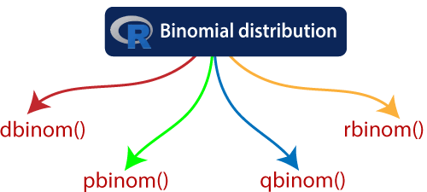

These function can have the following parameters:

|  |  |  |
| --- | --- | --- |
| **S.No** | **Parameter** | **Description** |
| 1. | x | It is a vector of numbers. |
| 2. | p | It is a vector of probabilities. |
| 3. | n | It is a vector of observations. |
| 4. | size | It is the number of trials. |
| 5. | prob | It is the probability of the success of each trial. |

Let's start understanding how these functions are used with the help of the examples

dbinom(): Direct Look-Up, Points

The dbinom() function of R calculates the probability density distribution at each point. In simple words, it calculates the density function of the particular binomial distribution.

**Example**

1. # Creating a sample of 100 numbers which are incremented by 1.5.
2. x **<-** seq(0,100,by = 1)
3. # Creating the binomial distribution.
4. y **<-** dbinom(x,50,0.5)
5. # Giving a name to the chart file.
6. png(file = "dbinom.png")
7. # Plotting the graph.
8. plot(x,y)
9. # Saving the file.
10. dev.off()

**Output:**

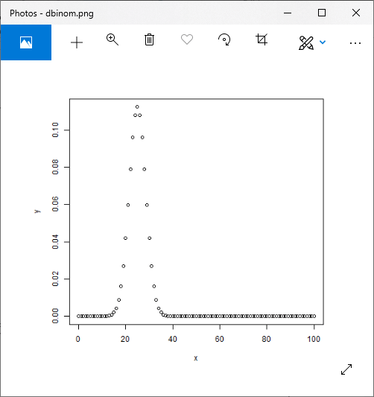

pbinom():Direct Look-Up, Intervals

The dbinom() function of R calculates the cumulative probability(a single value representing the probability) of an event. In simple words, it calculates the cumulative distribution function of the particular binomial distribution.

**Example**

1. # Probability of getting 20 or fewer heads from 48 tosses of a coin.
2. x **<-** pbinom(20,48,0.5)
3. #Showing output
4. print(x)

**Output:**

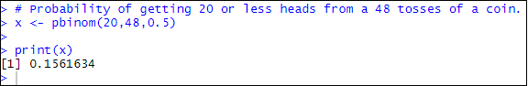

qbinom(): Inverse Look-Up

The qbinom() function of R takes the probability value and generates a number whose cumulative value matches with the probability value. In simple words, it calculates the inverse cumulative distribution function of the binomial distribution.

Let's find the number of heads that have a probability of 0.45 when a coin is tossed 51 times.

**Example**

1. # Finding number of heads with the  help of qbinom() function
2. x **<-** qbinom(0.45,48,0.5)
3. #Showing output
4. print(x)

**Output:**

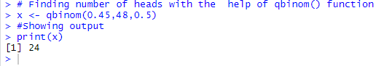

rbinom()

The rbinom() function of R is used to generate required number of random values for given probability from a given sample.

Let's see an example in which we find nine random values from a sample of 160 with a probability of 0.5.

**Example**

1. # Finding random values
2. x **<-** rbinom(9,160,0.5)
3. #Showing output
4. print(x)

**Output:**

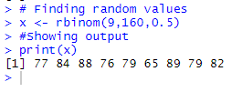

**POISSON DISTRIBUTION:**

In R, you can work with the Poisson distribution using built-in functions and packages. The Poisson distribution is commonly used to model the number of events or occurrences within a fixed interval of time or space when events are rare and independent. Here's how you can work with Poisson distributions in R:

**1. Generating Poisson Random Variables:**

You can generate random variables from a Poisson distribution using the **rpois()** function. This function takes two arguments: the number of random variables to generate (**n**) and the mean rate of occurrence (**lambda**).

# Generate 10 random variables from a Poisson distribution with lambda = 2

random_variables <- rpois(n = 10, lambda = 2)

print(random_variables)

#

This code will generate an array of 10 random Poisson-distributed values with a mean rate of occurrence (lambda) equal to 2.

**2. Calculating Poisson Probabilities:**

You can calculate the probability mass function (PMF) of the Poisson distribution for a given number of events (**x**) and mean rate of occurrence (**lambda**) using the **dpois()** function:

R

# Calculate the probability of observing exactly 3 events with lambda = 2

probability <- dpois(x = 3, lambda = 2)

print(probability)

This code will calculate the probability of observing exactly 3 events in a Poisson distribution with a mean rate of occurrence (lambda) equal to 2.

**3. Cumulative Poisson Probabilities:**

To calculate the cumulative distribution function (CDF) of the Poisson distribution (i.e., the probability of observing up to a certain number of events), you can use the **ppois()** function:

# Calculate the cumulative probability of observing up to 4 events with lambda = 2

cumulative_probability <- ppois(q = 4, lambda = 2)

print(cumulative_probability)

This code will calculate the probability of observing up to 4 events in a Poisson distribution with a mean rate of occurrence (lambda) equal to 2.

**4. Plotting Poisson Probability Mass Function:**

You can visualize the Poisson PMF using the **barplot()** function to create a bar plot. Here's an example:

# Plot the PMF of a Poisson distribution with lambda = 3 for values 0 to 10

lambda <- 3

x_values <- 0:10

pmf_values <- dpois(x = x_values, lambda = lambda)

barplot(pmf_values, names.arg = x_values, xlab = "Number of Events", ylab = "Probability", main = "Poisson PMF")

This code will create a bar plot of the Poisson PMF for lambda = 3 from 0 to 10 events.

These are some basic operations you can perform with Poisson distributions in R. R provides a rich set of functions and packages for working with probability distributions, making it a powerful tool for statistical analysis and modeling.

**R POISSON REGRESSION**

The **Poisson Regression** model is used for modeling events where the outcomes are counts. Count data is a discrete data with non-negative integer values that count things, such as the number of people in line at the grocery store, or the number of times an event occurs during the given timeframe.

We can also define the **count data** as the rate data. So that it can express the number of times an event occurs within the timeframe as a raw count or as a rate. Poisson regression allows us to determine which explanatory variable (x values) influence a given response variable (y value, count, or a rate).

**For example,** poisson regression can be implemented by a grocery store to understand better, and predict the number of people in a row.

There is the following general mathematical equation for poisson regression:

Here,

|  |  |  |
| --- | --- | --- |
| **S.No** | **Parameter** | **Description** |
| 1. | y | It is the response variable. |
| 2. | a and b | These are the numeric coefficients. |
| 3. | x | x is the predictor variable. |

The poisson regression model is created with the help of the familiar function glm().

Let's see an example in which we create the poisson regression model using glm() function. In this example, we have considered an in-built dataset "wrapbreaks" that describe the tension(low, medium, or high), and the effect of wool type(A and B) on the number of wrap breaks per loom. We will consider wool "type" and "tension"as the predictor variables, and "breaks" is taken as the response variable.

**Example**

1. #Creting data for the poisson regression
2. reg_data**<-warpbreaks**
3. print(head(reg_data))

**Output:**

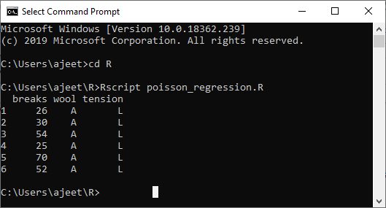

Now, we will create the regression model with the help of the glm() function as:

1. #Creating Poisson Regression Model using glm() function
2. output_result **<-glm**(formula = breaks ~ wool+tension, data = warpbreaks,family = poisson)
3. output_result

**Output:**

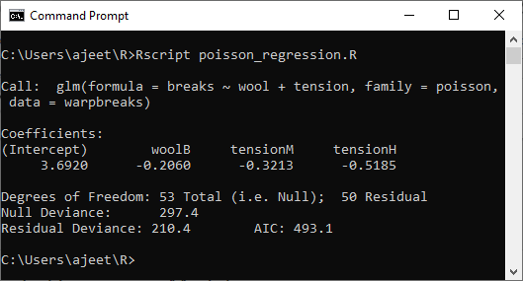

Now, let's use summary() function to find the summary of the model for data analysis.

1. #Using summary function
2. print(summary(output_result))

**Output:**

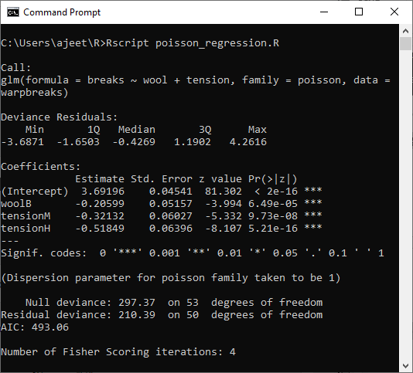

**BASIC STATISTIC**

Basic statistics are fundamental concepts and techniques used to summarize, analyze, and interpret data. They provide essential tools for understanding data distributions, making data-driven decisions, and drawing meaningful conclusions from data. Here are some of the most common basic statistics:

1. **Measures of Central Tendency:**
   * **Mean:** The arithmetic average of a set of values. It is calculated by summing all the values and dividing by the number of values.
   * **Median:** The middle value of a dataset when it is ordered. It separates the data into two equal halves.
   * **Mode:** The value that occurs most frequently in a dataset.
2. **Measures of Dispersion (Variability):**
   * **Range:** The difference between the maximum and minimum values in a dataset.
   * **Variance:** A measure of how data points deviate from the mean. It is calculated as the average of the squared differences between each data point and the mean.
   * **Standard Deviation:** The square root of the variance. It measures the average deviation of data points from the mean.
3. **Measures of Position:**
   * **Percentiles:** Values that divide a dataset into 100 equal parts. The 50th percentile is the median.
   * **Quartiles:** Values that divide a dataset into four equal parts. The first quartile (Q1) is the 25th percentile, the second quartile (Q2) is the median, and the third quartile (Q3) is the 75th percentile.
4. **Skewness:** A measure of the asymmetry or lack of symmetry in a dataset's distribution. Positive skewness indicates a long right tail, while negative skewness indicates a long left tail.
5. **Kurtosis:** A measure of the "tailedness" of a dataset's distribution. It quantifies how sharply the data's distribution peaks or flattens compared to a normal distribution.
6. **Frequency Distribution:** A tabular representation of data that shows how often each value occurs in a dataset. It can be used to create histograms and other graphical representations of data.
7. **Correlation:** A statistical measure that quantifies the strength and direction of the linear relationship between two variables. The correlation coefficient ranges from -1 (perfect negative correlation) to 1 (perfect positive correlation).
8. **Regression:** A statistical method used to model the relationship between one or more independent variables and a dependent variable. Linear regression is a common technique used for this purpose.
9. **Probability:** The likelihood of an event occurring. It is often expressed as a number between 0 (impossible) and 1 (certain).
10. **Hypothesis Testing:** A formal process for evaluating whether observed differences or relationships in data are statistically significant or if they could have occurred by chance.
11. **Confidence Intervals:** A range of values that is likely to contain an unknown population parameter with a certain level of confidence. Commonly used confidence levels are 95% and 99%.
12. **Sampling:** The process of selecting a subset (sample) of data from a larger population for analysis. Proper sampling techniques are essential for making inferences about a population.

These basic statistics are the building blocks of more advanced statistical techniques and data analysis. They provide valuable insights into data patterns, help in making informed decisions, and are used across various fields, including science, business, economics, and social sciences, to extract meaning from data.

**CORRELATION AND COVARIANCE**

Correlation and covariance are both statistical measures used to describe the relationship between two variables. They help us understand how changes in one variable are associated with changes in another. However, they serve slightly different purposes and have different interpretations:

**Covariance:**

* Covariance is a measure of the degree to which two variables change together. It quantifies the direction of the linear relationship between two variables.
* Mathematically, the covariance between two variables, X and Y, is calculated as:

*Cov*(*X*,*Y*)=*n*1​∑*i*=1*n*​(*Xi*​−*X*ˉ)(*Yi*​−*Y*ˉ) Where:

*Cov*(*X*,*Y*) is the covariance between X and Y.

* + *Xi*​ and *Yi*​ are individual data points.
  + ˉ*X*ˉ and *Y*ˉ are the means (averages) of X and Y, respectively.
  + *n* is the number of data points.
* Covariance can be positive, negative, or zero:
  + Positive covariance indicates that as one variable increases, the other tends to increase as well.
  + Negative covariance indicates that as one variable increases, the other tends to decrease.
  + Zero covariance indicates no linear relationship between the variables.

**Correlation:**

* Correlation is a standardized measure of the strength and direction of the linear relationship between two variables. It provides a more interpretable measure than covariance because it scales the relationship to a range between -1 and 1.
* The most commonly used measure of correlation is the Pearson correlation coefficient, often denoted as *r*. It is calculated as: *r*=*sX*​⋅*sY*​*Cov*(*X*,*Y*)​ Where:
  + *Cov*(*X*,*Y*) is the covariance between X and Y.
  + *sX*​ and *sY*​ are the standard deviations of X and Y, respectively.
* The Pearson correlation coefficient *r* can take values between -1 and 1:
  + 1*r*=1 indicates a perfect positive linear relationship.
  + −1*r*=−1 indicates a perfect negative linear relationship.
  + 0*r*=0 indicates no linear relationship.

Correlation is particularly useful because it not only tells you if two variables are related but also quantifies the strength and direction of that relationship in a way that is independent of the units of measurement. It's a common tool for analyzing relationships in various fields, including finance, social sciences, and natural sciences.

In summary, while covariance measures the joint variability of two variables, correlation provides a standardized measure of the strength and direction of their linear relationship. Correlation is often preferred in practice because it is easier to interpret and compare across different datasets.

Correlation analysis is a statistical method used to measure the strength of the linear relationship between two variables and compute their association. Correlation analysis calculates the level of change in one variable due to the change in the other. A high correlation points to a strong relationship between the two variables, while a low correlation means that the variables are weakly related.

Researchers use correlation analysis to analyze quantitative data collected through research methods like surveys and live polls for market research. They try to identify relationships, patterns, significant connections, and trends between two variables or datasets. There is a positive correlation between two variables when an increase in one variable leads to an increase in the other. On the other hand, a negative correlation means that when one variable increases, the other decreases and vice-versa.

Correlation is a bivariate analysis that measures the strength of association between two variables and the direction of the relationship. In terms of the strength of the relationship, the correlation coefficient's value varies between +1 and -1. A value of ± 1 indicates a perfect degree of association between the two variables.

As the correlation coefficient value goes towards 0, the relationship between the two variables will be weaker. The coefficient sign indicates the direction of the relationship; a + sign indicates a positive relationship, and a - sign indicates a negative relationship.

### Why Correlation Analysis is Important

Correlation analysis can reveal meaningful relationships between different metrics or groups of metrics. Information about those connections can provide new insights and reveal interdependencies, even if the metrics come from different parts of the business.

Suppose there is a strong correlation between two variables or metrics, and one of them is being observed acting in a particular way. In that case, you can conclude that the other one is also being affected similarly. This helps group related metrics together to reduce the need for individual data processing.

### Types of Correlation Analysis in Data Mining

Usually, in statistics, we measure four types of correlations: Pearson correlation, Kendall rank correlation, Spearman correlation, and the Point-Biserial correlation.

**1. Pearson r correlation**

Pearson r correlation is the most widely used correlation statistic to measure the degree of the relationship between linearly related variables. For example, in the stock market, if we want to measure how two stocks are related to each other, Pearson r correlation is used to measure the degree of relationship between the two. The point-biserial correlation is conducted with the Pearson correlation formula, except that one of the variables is dichotomous. The following formula is used to calculate the Pearson r correlation:

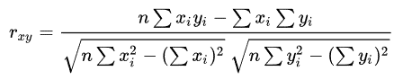

rxy= Pearson r correlation coefficient between x and y

n= number of observations

xi = value of x (for ith observation)

yi= value of y (for ith observation)

**2. Kendall rank correlation**

Kendall rank correlation is a non-parametric test that measures the strength of dependence between two variables. Considering two samples, a and b, where each sample size is n, we know that the total number of pairings with a b is n(n-1)/2. The following formula is used to calculate the value of Kendall rank correlation:

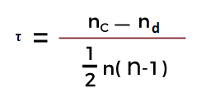

Nc= number of concordant

Nd= Number of discordant

**3. Spearman rank correlation**

Spearman rank correlation is a non-parametric test that is used to measure the degree of association between two variables. The Spearman rank correlation test does not carry any assumptions about the data distribution. It is the appropriate correlation analysis when the variables are measured on an at least ordinal scale.

This coefficient requires a table of data that displays the raw data, its ranks, and the difference between the two ranks. This squared difference between the two ranks will be shown on a scatter graph, which will indicate whether there is a positive, negative, or no correlation between the two variables. The constraint that this coefficient works under is -1 ≤ r ≤ +1, where a result of 0 would mean that there was no relation between the data whatsoever. The following formula is used to calculate the Spearman rank correlation:

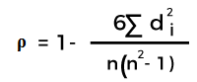

ρ= Spearman rank correlation

di= the difference between the ranks of corresponding variables

n= number of observations

### When to Use These Methods

The two methods outlined above will be used according to whether there are parameters associated with the data gathered. The two terms to watch out for are:

* **Parametric:**(Pearson's Coefficient) The data must be handled with the parameters of populations or probability distributions. Typically used with quantitative data already set out within said parameters.
* **Non-parametric:**(Spearman's Rank) Where no assumptions can be made about the probability distribution. Typically used with qualitative data, but can be used with quantitative data if Spearman's Rank proves inadequate.

In cases when both are applicable, statisticians recommend using the parametric methods such as Pearson's Coefficient because they tend to be more precise. But that doesn't mean discounting the non-parametric methods if there isn't enough data or a more specified accurate result is needed.

### Interpreting Results

Typically, the best way to gain a generalized but more immediate interpretation of the results of a set of data is to visualize it on a scatter graph such as these:

1. **Positive Correlation:** Any score from +0.5 to +1 indicates a very strong positive correlation, which means that they both increase simultaneously. This case follows the data points upwards to indicate the positive correlation. The line of best fit, or the trend line, places to best represent the graph's data.  
   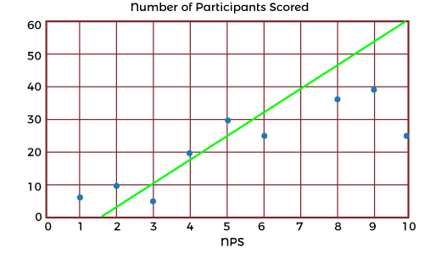
2. **Negative Correlation:** Any score from -0.5 to -1 indicates a strong negative correlation, which means that as one variable increases, the other decreases proportionally. The line of best fit can be seen here to indicate the negative correlation. In these cases, it will slope downwards from the point of origin.  
   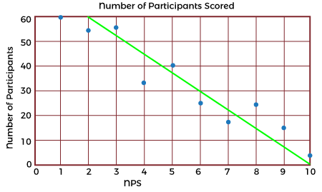
3. **No Correlation:** Very simply, a score of 0 indicates no correlation, or relationship, between the two variables. This fact will stand true for all, no matter which formula is used. The more data inputted into the formula, the more accurate the result will be. The larger the sample size, the more accurate the result.  
   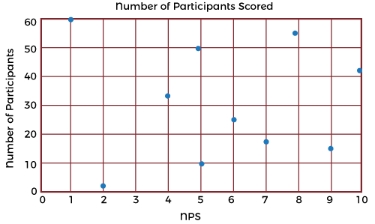

Outliers or anomalies must be accounted for in both correlation coefficients. Using a scatter graph is the easiest way of identifying any anomalies that may have occurred. Running the correlation analysis twice (with and without anomalies) is a great way to assess the strength of the influence of the anomalies on the analysis. Spearman's Rank coefficient may be used if anomalies are present instead of Pearson's Coefficient, as this formula is extremely robust against anomalies due to the ranking system used.

### Benefits of Correlation Analysis

Here are the following benefits of correlation analysis, such as:

**1. Reduce Time to Detection**

In anomaly detection, working with many metrics and surfacing correlated anomalous metrics helps draw relationships that reduce time to detection (TTD) and support shortened time to remediation (TTR). As data-driven decision-making has become the norm, early and robust detection of anomalies is critical in every industry domain, as delayed detection adversely impacts customer experience and revenue.

**2. Reduce Alert Fatigue**

Another important benefit of correlation analysis in anomaly detection is reducing alert fatigue by filtering irrelevant anomalies (based on the correlation) and grouping correlated anomalies into a single alert. Alert storms and false positives are significant challenges organizations face - getting hundreds, even thousands of separate alerts from multiple systems when many of them stem from the same incident.

**3. Reduce Costs**

Correlation analysis helps significantly reduce the costs associated with the time spent investigating meaningless or duplicative alerts. In addition, the time saved can be spent on more strategic initiatives that add value to the organization.

### Example Use Cases for Correlation Analysis

Marketing professionals use correlation analysis to evaluate the efficiency of a campaign by monitoring and testing customers' reactions to different marketing tactics. In this way, they can better understand and serve their customers.

Financial planners assess the correlation of an individual stock to an index such as the S&P 500 to determine if adding the stock to an investment portfolio might increase the portfolio's systematic risk.

For data scientists and those tasked with monitoring data, correlation analysis is incredibly valuable for root cause analysis and reduces time to detection (TTD) and remediation (TTR). Two unusual events or anomalies happening simultaneously/rate can help pinpoint an underlying cause of a problem. The organization will incur a lower cost of experiencing a problem if it can be understood and fixed sooner.

Technical support teams can reduce the number of alerts they must respond to by filtering irrelevant anomalies and grouping correlated anomalies into a single alert. Tools such as Security Information and Event Management (SIEM) systems automatically facilitate incident response.

### Does Correlation Imply Causation?

While correlation analysis techniques may identify a significant relationship, correlation does not imply causation. The analysis cannot determine the cause, nor should this conclusion be attempted. The significant relationship implies more understanding and extraneous or underlying factors that should be explored further to search for a cause. While a causal relationship may exist, any researcher would be remiss in using the correlation results to prove this existence.

The cause of any relationship discovered through the correlation analysis is for the researcher to determine through other means of statistical analysis, such as the coefficient of determination analysis. However, correlation analysis can provide a great amount of value; for example, the value of the dependency or the variables can be estimated, which can help firms estimate the cost and sale of a product or service.

In essence, the uses for and applications of correlation-based statistical analyses allow researchers to identify which aspects and variables are dependent on each other, which can generate actionable insights as they are or starting points for further investigations and deeper insights.

**T-TESTS**

A t-test is a statistical hypothesis test used to determine if there is a significant difference between the means of two groups or populations. It is commonly used in research and data analysis to assess whether the means of two samples are statistically different from each other. The t-test is based on the t-distribution, which is similar to the normal distribution but has heavier tails, making it more appropriate for small sample sizes.

There are different types of t-tests, and the choice of which one to use depends on the nature of the data and the research question. Here are the three most common types of t-tests:

1. **Independent Samples t-Test (Two-Sample t-Test):**
   * This test is used to compare the means of two independent groups or samples to determine if they are statistically different from each other.
   * The null hypothesis (*H*0​) typically assumes that there is no difference between the two group means, while the alternative hypothesis (*H*1​) suggests that there is a significant difference.
   * The test statistic is calculated as: =ˉ*t*=*n*1​*s*12​​+*n*2​*s*22​​​*X*ˉ1​−*X*ˉ2​​
   * Where:
     + *X*ˉ1​ and *X*ˉ2​ are the sample means of the two groups.
     + *s*1​ and2*s*2​ are the sample standard deviations of the two groups.
     + 1*n*1​ and 2*n*2​ are the sample sizes of the two groups.
   * The test statistic follows a t-distribution with degrees of freedom equal to 1+2−2*n*1​+*n*2​−2.
2. **Paired Samples t-Test:**
   * This test is used when you have two related or paired samples, and you want to determine if there is a significant difference in the means of the paired observations.
   * For example, it could be used to compare the before-and-after measurements of the same individuals in an experiment.
   * The null hypothesis (*H*0​) assumes that there is no difference in the means of the paired observations, while the alternative hypothesis (*H*1​) suggests that there is a significant difference.
   * The test statistic and degrees of freedom are similar to the independent samples t-test, but the paired samples t-test takes into account the paired nature of the data.
3. **One-Sample t-Test:**
   * This test is used to determine if the mean of a single sample is significantly different from a known or hypothesized population mean.
   * The null hypothesis (*H*0​) typically assumes that there is no difference between the sample mean and the population mean, while the alternative hypothesis (*H*1​) suggests a significant difference.
   * The test statistic is calculated as: =ˉ−*t*=*n*​*s*​*X*ˉ−*μ*​
   * Where:
     + ˉ*X*ˉ is the sample mean.
     + *μ* is the hypothesized population mean.
     + *s* is the sample standard deviation.
     + *n* is the sample size.
   * The test statistic follows a t-distribution with degrees of freedom equal to −1*n*−1.

In all types of t-tests, you calculate the test statistic, and then you compare it to the critical value from the t-distribution or use a p-value to determine whether to reject the null hypothesis. If the test statistic is far from zero (in either the positive or negative direction), it suggests a significant difference between the means, while a test statistic close to zero suggests no significant difference.

T-tests are widely used in various fields, including psychology, biology, economics, and social sciences, to test hypotheses and make inferences about population means based on sample data.

# T-Test in R

In statistics, the T-test is one of the most common test which is used to determine whether the mean of the two groups is equal to each other. The assumption for the test is that both groups are sampled from a normal distribution with equal fluctuation. The null hypothesis is that the two means are the same, and the alternative is that they are not identical. It is known that under the null hypothesis, we can compute a t-statistic that will follow a t-distribution with n1 + n2 - 2 degrees of freedom.



In R, there are various types of T-test like **one sample** and **Welch T-test**. R provides a t.test() function, which provides a variety of T-tests.

There are the following syntaxes of t.test() function for different T-test

**Independent 2-group T-test**

1. t.test(y~x)

here, y is numeric, and x is a binary factor.

**Independent 2-group T-test**

1. t.test(y1,y2)

Here, y1 and y2 are numeric.

**Paired T-test**

1. t.test(y1,y2,paired=TRUE)

Here, y1 & y2 are numeric.

**One sample T-test**

1. t.test(y,mu=3)

Here, Ho: mu=3

## How to perform T-tests in R

In the T-test, for specifying equal variances and a pooled variance estimate, we set var.equal=True. We can also use alternative="less" or alternative="greater" for specifying one-tailed test.

Let's see how one-sample, paired sample, and independent samples T-test is performed.

### One-Sample T-test

One-Sample T-test is a T-test which compares the mean of a vector against a theoretical mean. There is a following formula which is used to compute the T-test :

T-Test in R

Here,

1. M is the mean.
2. ? is the theoretical mean.
3. s is the standard deviation.
4. n is the number of observations.

For evaluating the statistical significance of the **t-test**, we need to compute the **p-value**. The p-value range starts from 0 to 1, and is interpreted as follow:

* If the p-value is lower than 0.05, it means we are strongly confident to reject the null hypothesis. So that H3 is accepted.
* If the p-value is higher than 0.05, then it indicates that we don't have enough evidence to reject the null hypothesis.

We construct the pvalue by looking at the corresponding absolute value of the t-test.

In R, we use the following syntax of t.test() function for performing a one-sample T-test in R.

1. t.test(x, ?=0)

Here,

1. x is the name of our variable of interest.
2. ? is described by the null hypothesis, which is set equal to the mean.

**Example**

Let's see an example of One-Sample T-test in which we test whether the volume of a shipment of wood was less than usual(?0=0).

1. set.seed(0)
2. ship_vol **<-** c(rnorm(70, mean = 35000, sd = 2000))
3. t.test(ship_vol, mu = 35000)

**Output:**

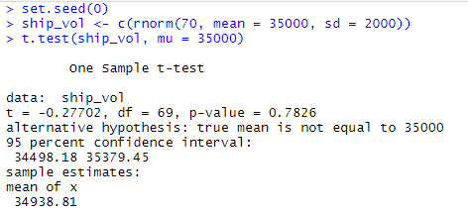

### Paired-Sample T-test

To perform a paired-sample test, we need two vectors data y1 and y2. Then, we will run the code using the syntax t.test (y1, y2, paired = TRUE).

**Example:**

Suppose, we work in a large health clinic, and we are testing a new drug Procardia, which aims to reduce high blood pressure. We find 13000 individuals with high systolic blood pressure (x 150 = 150 mmHg, SD = 10 mmHg), and we provide them with Procardia for a month, and then measure their blood pressure again. We find that the average systolic blood pressure decreased to 144 mmHg with a standard deviation of 9 mmHg.

1. set.seed(2800)
2. pre.treatment **<-** c(rnorm(2000, mean = 130, sd = 5))
3. post.treatment **<-** c(rnorm(2000, mean = 144, sd = 4))
4. t.test(pre_Treatment, post_Treatment, paired = TRUE)

**Output:**

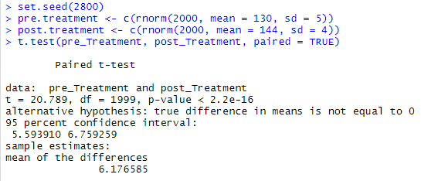

### Independent-Sample T-test

Depending on the structure of our data and the equality of their variance, the independent-sample T-test can take one of the three forms, which are as follows:

1. Independent-Samples T-test where y1 and y2 are numeric.
2. Independent-Samples T-test where y1 is numeric and y2 is binary.
3. Independent-Samples T-test with equal variances not assumed.

There is the following general form of t.test() function for the independent-sample t-test:

1. t.test(y1,y2, paired=FALSE)

By default, R assumes that the versions of y1 and y2 are unequal, thus defaulting to Welch's test. For toggling this, we set the flag var.equal=TRUE.

Let's see some examples in which we test the hypothesis. In this hypothesis, Clevelanders and New Yorkers spend different amounts for eating outside on a monthly basis.

**Example 1: Independent-Sample T-test where y1 and y2 are numeric**

1. set.seed(0)
2. Spenders.Cleve **<-** rnorm(50, mean = 300, sd = 70)
3. Spenders.NY **<-** rnorm(50, mean = 350, sd = 70)
4. t.test(Spenders.Cleve, Spenders.NY, var.equal = TRUE)

**Output:**

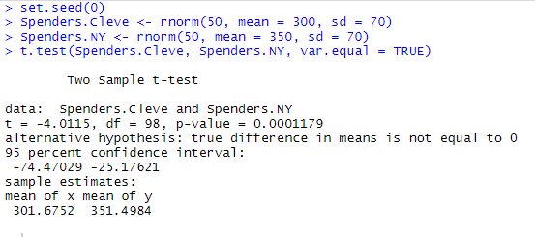

**Example 2: Where y1 is numeric and y2 are binary**

1. **set.seed(0)**
2. **Spenders.Cleve <- rnorm(50, mean = 300, sd = 70)**
3. **Spenders.NY <- rnorm(50, mean = 350, sd = 70)**
4. **Amount.Spent <- c(Spenders.Cleve, Spenders.NY)**
5. **city.name <- c(rep("Cleveland", 50), rep("New York", 50))**
6. **t.test(Amount.Spent ~ city.name, var.equal = TRUE)**

**Output:**

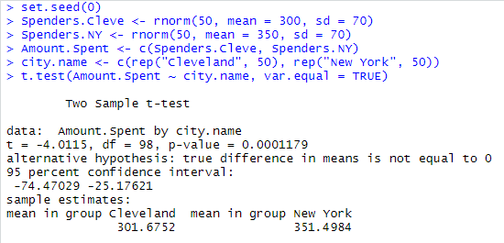

**Example 3: With equal variance not assumed**

1. **set.seed(0)**
2. **Spenders.Cleve <- rnorm(50, mean = 300, sd = 70)**
3. **Spenders.NY <- rnorm(50, mean = 350, sd = 70)**
4. **t.test(Spenders.Cleve, Spenders.NY, var.equal = FALSE)**

**Output:**

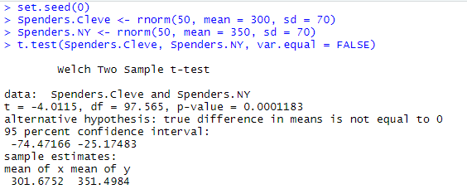

**CHI-SQUARE TEST**

The chi-square test is a statistical test used to determine if there is a significant association or independence between two categorical variables. It is commonly used to analyze data that can be arranged in a contingency table, which is a table that displays the frequencies or counts of observations for different categories of two or more categorical variables.

There are several variations of the chi-square test, each suited to different types of data and research questions. Here are two common types:

1. **Chi-Square Test for Independence (Chi-Square Test of Association):**
   * This test is used to determine whether there is a significant association between two categorical variables.
   * The null hypothesis (*H*0​) assumes that the two variables are independent, meaning there is no association between them.
   * The alternative hypothesis (*H*1​) suggests that there is a significant association between the two variables.
   * The test is typically applied to data in the form of a contingency table, where the rows represent one categorical variable, and the columns represent the other categorical variable.
   * The test statistic is calculated as the chi-square (2*χ*2) statistic, which measures the difference between the observed and expected frequencies in the contingency table.
   * The chi-square statistic follows a chi-square distribution with degrees of freedom equal to (−1)(−1)(*r*−1)(*c*−1), where *r* is the number of rows and *c* is the number of columns in the contingency table.
   * You can use the chi-square statistic to calculate a p-value, which helps you determine whether to reject the null hypothesis. If the p-value is below a chosen significance level (e.g., 0.05), you reject the null hypothesis, indicating a significant association.
2. **Chi-Square Goodness-of-Fit Test:**
   * This test is used to determine whether observed data follows a specified theoretical distribution or expected proportions.
   * The null hypothesis (*H*0​) assumes that the observed data fits the expected distribution, while the alternative hypothesis (*H*1​) suggests that there is a significant difference between the observed and expected distributions.
   * The test is often applied when you have a single categorical variable and want to compare the observed frequencies in each category to the expected frequencies based on a hypothesized distribution.
   * The test statistic is again the chi-square (2*χ*2) statistic, which measures the difference between the observed and expected frequencies.
   * The degrees of freedom depend on the number of categories minus one and any parameters estimated from the data.
   * Like in the chi-square test for independence, you calculate a p-value and compare it to a chosen significance level to determine whether to reject the null hypothesis.

Chi-square tests are widely used in fields such as biology, social sciences, and market research to examine relationships between categorical variables and to assess goodness-of-fit of data to expected distributions. They are powerful tools for analyzing categorical data and making inferences about population characteristics based on sample data.

Chi-Square Test

The **Chi-Square Test** is used to analyze the frequency table (i.e., contingency table), which is formed by two categorical variables. The chi-square test evaluates whether there is a significant relationship between the categories of the two variables.

The Chi-Square Test is a statistical method which is used to determine whether two categorical variables have a significant correlation between them. These variables should be from the same population and should be categorical like- Yes/No, Red/Green, Male/Female, etc.

R provides **chisq.test()** function to perform chi-square test. This function takes data as an input, which is in the table form, containing the count value of the variables in the observation.



In R, there is the following syntax of chisq.test() function:

1. chisq.test(data)

Let's see an example in which we will take the Cars93 data present in the "Mass" library. This data represents the sales of different models of cars in the year 1993.

**Data:**

1. library("MASS")
2. print(str(Cars93))

**Output:**

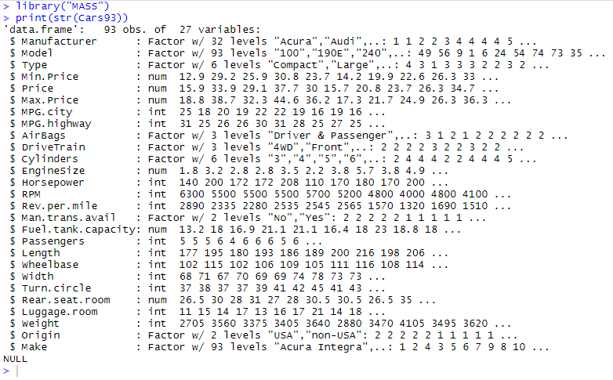

**Example:**

1. # Loading the Mass library.
2. library("MASS")
3. # Creating a data frame from the main data set.
4. car_data**<-** data.frame(Cars93$AirBags, Cars93$Type)
5. # Creating a table with the needed variables.
6. car_data = table(Cars93$AirBags, Cars93$Type)
7. print(car_data)
8. # Performing the Chi-Square test.
9. print(chisq.test(car_data))

**Output:**

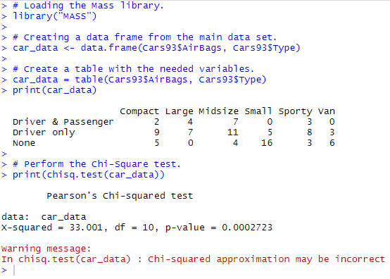

**ANOVA TEST**

ANOVA, or Analysis of Variance, is a statistical technique used to analyze the differences among the means of three or more groups or populations. ANOVA is an extension of the t-test, which is used to compare the means of two groups. ANOVA allows you to determine whether there are statistically significant differences between the means of multiple groups and, if so, which groups are different from each other. ANOVA is commonly used in experimental research to assess the impact of one or more independent variables on a dependent variable.

There are different types of ANOVA tests, depending on the study design and the number of independent variables involved:

1. **One-Way ANOVA (One-Factor ANOVA):**
   * One-Way ANOVA is used when there is one independent variable (factor) with three or more levels or groups.
   * The null hypothesis (0*H*0​) assumes that there are no significant differences between the group means, while the alternative hypothesis (1*H*1​) suggests that at least one group mean is different from the others.
   * The test calculates an F-statistic, which is the ratio of the between-group variance to the within-group variance.
   * If the F-statistic is statistically significant (i.e., it exceeds a critical value), you reject the null hypothesis and conclude that at least one group mean is different.
2. **Two-Way ANOVA (Two-Factor ANOVA):**
   * Two-Way ANOVA is used when there are two independent variables (factors) and you want to assess their main effects as well as any interaction effect between them.
   * It allows you to analyze how two factors independently or jointly affect a dependent variable.
   * The factors can be either categorical or continuous variables.
   * It provides information about main effects for each factor and the interaction effect between the factors.
3. **Multivariate Analysis of Variance (MANOVA):**
   * MANOVA is an extension of ANOVA that allows you to analyze multiple dependent variables simultaneously while considering the effects of one or more independent variables.
   * It is used when you have multiple dependent variables and want to assess whether the groups differ on these variables.

Key components of ANOVA include:

* **Sum of Squares (SS):** ANOVA decomposes the total variation in the data into different sources, including the variation between groups (explained by the independent variable) and the variation within groups (unexplained or error variation).
* **Degrees of Freedom (df):** These represent the number of categories or levels minus one for each factor. Degrees of freedom are used to calculate the F-statistic.
* **F-Statistic:** The F-statistic is calculated as the ratio of the between-group variation to the within-group variation. A larger F-statistic indicates a greater likelihood of rejecting the null hypothesis.
* **P-Value:** The p-value associated with the F-statistic is used to determine whether the differences between group means are statistically significant. A small p-value (typically less than 0.05) suggests significant differences.

ANOVA is a versatile and powerful statistical method used in various fields, including psychology, biology, social sciences, and experimental sciences, to analyze the effects of independent variables on dependent variables across multiple groups or conditions.

**LINEAR MODELS IN R**

In R, you can create and analyze linear models using various functions and packages. Linear models are used to establish relationships between one or more independent variables (predictors) and a dependent variable (response) by fitting a linear equation to the data. Here's a basic overview of how to work with linear models in R:

1. **Linear Regression with lm():**
   * The most common linear model is simple linear regression, which models a linear relationship between a single independent variable and a dependent variable.
   * You can use the **lm()** function to create a linear regression model in R. Here's a simple example:

**# Create a linear regression model**

**model <- lm(response_variable ~ predictor_variable, data =your_data_frame)**

**# View the model summary**

**summary(model)**

* + Replace **response_variable** and **predictor_variable** with the actual variable names from your dataset and **your_data_frame** with your data.
  + The **summary()** function provides detailed information about the model, including coefficients, R-squared value, p-values, and more.

1. **Multiple Linear Regression:**
   * In multiple linear regression, you can model the relationship between a dependent variable and multiple independent variables.
   * You can extend the **lm()** function to include multiple predictors. For example:

# Create a multiple linear regression model

model <- lm(response_variable ~ predictor1 + predictor2 + predictor3, data = your_data_frame)

# View the model summary

summary(model)

In R, you can create and analyze linear models using various functions and packages. Linear models are used to establish relationships between one or more independent variables (predictors) and a dependent variable (response) by fitting a linear equation to the data. Here's a basic overview of how to work with linear models in R:

1. **Linear Regression with lm():**
   * The most common linear model is simple linear regression, which models a linear relationship between a single independent variable and a dependent variable.
   * You can use the **lm()** function to create a linear regression model in R. Here's a simple example:
   * Replace **response_variable** and **predictor_variable** with the actual variable names from your dataset and **your_data_frame** with your data.
   * The **summary()** function provides detailed information about the model, including coefficients, R-squared value, p-values, and more.
2. **Multiple Linear Regression:**
   * In multiple linear regression, you can model the relationship between a dependent variable and multiple independent variables.
   * You can extend the **lm()** function to include multiple predictors. For example:

model summary summary(model)

1. **Nonlinear Regression:**
   * Linear models assume a linear relationship between variables. If your data suggests a nonlinear relationship, you can use nonlinear regression models.
   * The **nls()** function is used for nonlinear regression in R.
2. **Generalized Linear Models (GLM):**
   * Linear models can be extended to handle non-normal distribution and non-continuous data types. Generalized linear models (GLM) are used for this purpose.
   * The **glm()** function is used to create GLMs. You specify the family of the distribution, such as Gaussian (for normal distribution), binomial (for binary outcomes), Poisson (for count data), etc.

# Create a binomial GLM (logistic regression) model

model <- glm(response_variable ~ predictor_variable, data = your_data_frame, family = binomial)

# View the model summary

summary(model)

1. **Assessing Model Fit:**
   * After fitting a linear model, you should assess its fit and assumptions.
   * Common diagnostic plots and functions include **plot()**, **residuals()**, and visualizations like scatterplots, residual plots, and quantile-quantile (Q-Q) plots.
2. **Predictions and Inference:**
   * You can use the **predict()** function to make predictions using your linear model.
   * For hypothesis testing and confidence intervals, use functions like **confint()** and **hypothesis()** from the **car** package.

# Make predictions

predictions <- predict(model, newdata = new_data_frame)

# Calculate confidence intervals for coefficients

conf_intervals <- confint(model)

# Test hypotheses about coefficients

hypothesis(model, "predictor_variable = 0")

1. **ANOVA and Model Comparison:**
   * You can compare models using ANOVA or likelihood ratio tests to determine which model provides a better fit for the data.

These are the fundamental steps for working with linear models in R. Depending on your specific analysis and dataset, you may need to explore additional packages and techniques to handle more complex modeling scenarios and data types. The **stats** package provides basic linear modeling functionality, while packages like **glmnet**, **lme4**, and **mgcv** offer more advanced modeling capabilities.

**SIMPLE LINEAR REGRESSION IN R**

Simple linear regression in R is a statistical technique used to model the relationship between a single independent variable (predictor) and a dependent variable (response) using a linear equation. In simple linear regression, we aim to find the best-fitting linear model that describes how the response variable changes with changes in the predictor variable. Here's how to perform simple linear regression in R:

Assuming you have a dataset with a response variable (Y) and a predictor variable (X), and you want to fit a simple linear regression model:

1. **Load Your Data:**
   * Load your dataset into R using functions like **read.csv()**, **read.table()**, or any other appropriate data loading function.

**# Load your data**

**data <- read.csv("your_data.csv")**

**Explore Your Data:**

* Before fitting the model, it's essential to understand your data by exploring summary statistics, visualizations, and relationships between variables. Use functions like **summary()**, **plot()**, and others to explore the datase

**# Explore your data**

**summary(data)**

**plot(data$X, data$Y, main = "Scatterplot of X vs. Y")**

**Fit the Simple Linear Regression Model:**

* Use the **lm()** function to fit the simple linear regression model. Specify the formula with your response variable (~) and predictor variable.

**View Model Summary:**

* To view detailed information about the linear regression model, use the **summary()** function on the fitted model object.

**# View model summary**

**summary(model)**

1. The summary will provide coefficients, R-squared value, p-values, and other statistics.
2. **Visualize the Regression Line:**
   * You can visualize the fitted regression line along with your data points using the **plot()** function. This helps you visualize how well the model fits the data.

**# Visualize the regression line**

**plot(data$X, data$Y, main = "Scatterplot of X vs. Y")**

**abline(model, col = "red")**

1. This code plots the original data points and overlays the fitted regression line in red.
2. **Make Predictions:**
   * You can use the **predict()** function to make predictions based on your fitted model.

**# Make predictions**

**new_data <- data.frame(X = c(5, 7, 10)) # Example predictor values**

**predictions <- predict(model, newdata = new_data)**

1. Replace the values in **new_data** with the predictor values for which you want to make predictions.
2. **Assess Model Fit:**
   * Assess the goodness of fit by examining residual plots, checking assumptions, and using diagnostic tests. You can use functions like **plot()**, **residuals()**, and diagnostic plots to evaluate the model.

This is a basic outline of how to perform simple linear regression in R. It's essential to understand the assumptions of linear regression and to check them to ensure the validity of your model. Additionally, you may want to explore more advanced topics such as model selection, model validation, and handling multicollinearity for more complex regression analyses.

**MULTIPLE REGRESSION**

Multiple regression is a statistical technique used to model the relationship between a dependent variable (response) and two or more independent variables (predictors) using a linear equation. It extends the concept of simple linear regression, where you model the relationship between a single predictor and the dependent variable. Multiple regression allows you to account for multiple predictors and their combined effects on the response variable. Here's how to perform multiple regression in R:

Assuming you have a dataset with a response variable (Y) and multiple predictor variables (X1, X2, X3, etc.), and you want to fit a multiple regression model:

1. **Load Your Data:**
   * Load your dataset into R as described earlier using functions like **read.csv()** or **read.table()**.

**# Load your data**

**data <- read.csv("your_data.csv")**

**Explore Your Data:**

* Explore your data to understand its characteristics and relationships among variables using functions like **summary()**, **plot()**, and correlation matrices.

**# Explore your data**

**summary(data)**

**pairs(data[, c("Y", "X1", "X2", "X3")]) # Create a scatterplot matrix for relevant variables**

**Fit the Multiple Regression Model:**

* Use the **lm()** function to fit the multiple regression model. Specify the formula with your response variable (~) and all predictor variables.

**# Fit the multiple regression model**

**model <- lm(Y ~ X1 + X2 + X3, data = data)**

1. Include all relevant predictor variables in the formula, separated by plus signs.
2. **View Model Summary:**
   * To view detailed information about the multiple regression model, use the **summary()** function on the fitted model object.

**# View model summary**

**summary(model)**

1. The summary will provide coefficients, R-squared value, p-values, and other statistics for each predictor.
2. **Visualize Model Results:**
   * You can visualize the relationships between the predictors and the response using various plotting techniques. For example, you can use scatterplots, partial regression plots, and residual plots.

# Visualize relationships

plot(data$X1, data$Y, main = "Scatterplot of X1 vs. Y")

plot(data$X2, data$Y, main = "Scatterplot of X2 vs. Y")

plot(data$X3, data$Y, main = "Scatterplot of X3 vs. Y")

**Make Predictions:**

* You can use the **predict()** function to make predictions based on your fitted multiple regression model.

# Make predictions

new_data <- data.frame(X1 = c(5, 7, 10), X2 = c(2, 3, 4), X3 = c(8, 6, 9)) # Example predictor values

predictions <- predict(model, newdata = new_data)

1. Replace the values in **new_data** with the predictor values for which you want to make predictions.
2. **Assess Model Fit:**
   * Assess the goodness of fit, check model assumptions, and perform diagnostic tests as you would with simple linear regression.

Multiple regression is a powerful tool for analyzing the relationships between multiple predictors and a response variable. It's essential to interpret the coefficients, evaluate model assumptions, and validate the model to ensure its accuracy and usefulness for making predictions or drawing conclusions.

Multiple linear regression is the extension of the simple linear regression, which is used to predict the outcome variable (y) based on multiple distinct predictor variables (x). With the help of three predictor variables (x1, x2, x3), the prediction of y is expressed using the following equation:

y=b0+b1*x1+b2*x2+b3*x3

The "b" values represent the regression weights. They measure the association between the outcome and the predictor variables. "

**Or**

Multiple linear regression is the extension of linear regression in the relationship between more than two variables. In simple linear regression, we have one predictor and one response variable. But in multiple regressions, we have more than one predictor variable and one response variable.

There is the following general mathematical equation for multiple regression -

y=b0+b1*x1+b2*x2+b3*x3+⋯bn*xn

Here,

* **y** is a response variable.
* **b0, b1, b2...bn** are the coefficients.
* **x1, x2, ...xn** are the predictor variables.

In R, we create the regression model with the help of the **lm()** function. The model will determine the value of the coefficients with the help of the input data. We can predict the value of the response variable for the set of predictor variables using these coefficients.

There is the following syntax of lm() function in multiple regression

1. lm(y ~ x1+x2+x3...., data)

Before proceeding further, we first create our data for multiple regression. We will use the "mtcars" dataset present in the R environment. The main task of the model is to create the relationship between the "mpg" as a response variable with "wt", "disp" and "hp" as predictor variables.

For this purpose, we will create a subset of these variables from the "mtcars" dataset.

1. data**<-mtcars**[,c("mpg","wt","disp","hp")]
2. print(head(input))

Creating Relationship Model and finding Coefficient

Now, we will use the data which we have created before to create the Relationship Model. We will use the lm() function, which takes two parameters i.e., formula and data. Let's start understanding how the lm() function is used to create the Relationship Model.

**Example**

1. #Creating input data.
2. input **<-** mtcars[,c("mpg","wt","disp","hp")]
3. # Creating the relationship model.
4. Model **<-** lm(mpg~wt+disp+hp, data = input)
5. # Showing the Model.
6. print(Model)

**Output:**

From the above output it is clear that our model is successfully setup. Now, our next step is to find the coefficient with the help of the model.

b0<- coef(Model)[1]

print(b0)

x_wt<- coef(Model)[2]

x_disp<- coef(Model)[3]

x_hp<- coef(Model)[4]

print(x_wt)

print(x_disp)

print(x_hp)

**Output:**

The equation for the Regression Model

Now, we have coefficient values and intercept. Let's start creating a mathematical equation that we will apply for predicting new values. First, we will create an equation, and then we use the equation to predict the mileage when a new set of values for weight, displacement, and horsepower is provided.

Let's see an example in which we predict the mileage for a car with weight=2.51, disp=211 and hp=82.

**Example**

1. #Creating equation for predicting new values.
2. y=b0+x_wt*x1+x_disp*x2+x_hp*x3\
3. #Applying equation for prediction new values
4. y=b0+x_wt*2.51+x_disp*211+x_hp*82

**LOGISTIC REGRESSION, IN R**

Logistic regression is a statistical method used for modeling the relationship between a binary dependent variable (response) and one or more independent variables (predictors) by estimating the probabilities of class membership. It's commonly used for classification tasks, where the dependent variable represents two classes (e.g., yes/no, 0/1, true/false).

To perform logistic regression in R, follow these steps:

Assuming you have a dataset with a binary response variable (Y) and one or more predictor variables (X1, X2, X3, etc.), and you want to fit a logistic regression model:

1. **Load Your Data:**
   * Load your dataset into R using functions like **read.csv()**, **read.table()**, or any other data loading function.

**# Load your data**

**data <- read.csv("your_data.csv")**

**Explore Your Data:**

* Explore your data to understand its characteristics and relationships among variables using functions like **summary()**, **plot()**, and correlation matrices.

**# Explore your data**

**summary(data)**

**pairs(data[, c("Y", "X1", "X2", "X3")]) # Create a scatterplot matrix for relevant variables**

**Fit the Logistic Regression Model:**

* Use the **glm()** function (Generalized Linear Model) with the family argument set to "binomial" to fit the logistic regression model. Specify the formula with your binary response variable (~) and all predictor variables.

**# Fit the logistic regression model**

**model <- glm(Y ~ X1 + X2 + X3, data = data, family = binomial)**

1. Include all relevant predictor variables in the formula, separated by plus signs.
2. **View Model Summary:**
   * To view detailed information about the logistic regression model, use the **summary()** function on the fitted model object.

R

**# View model summary**

**summary(model)**

1. The summary will provide coefficients, p-values, and other statistics for each predictor.
2. **Make Predictions:**
   * You can use the **predict()** function to make predictions based on your fitted logistic regression model.

**# Make predictions**

**new_data <- data.frame(X1 = c(5, 7, 10), X2 = c(2, 3, 4), X3 = c(8, 6, 9)) # Example predictor values**

**predictions <- predict(model, newdata = new_data, type = "response")**

1. Replace the values in **new_data** with the predictor values for which you want to make predictions. The **type = "response"** argument ensures that the predictions are probabilities.
2. **Assess Model Fit:**
   * Assess the goodness of fit, check model assumptions, and perform diagnostic tests specific to logistic regression, such as ROC curves and confusion matrices.

Logistic regression is commonly used for binary classification tasks in various fields, including medicine, marketing, finance, and machine learning. It's important to interpret the coefficients, evaluate the model's performance, and select appropriate predictors for your specific problem. Additionally, consider techniques like regularization (e.g., L1 or L2 regularization) for model improvement.

R-Logistic Regression

In the logistic regression, a regression curve, y = f (x), is fitted. In the regression curve equation, y is a categorical variable. This Regression Model is used for predicting that y has given a set of predictors x. Therefore, predictors can be categorical, continuous, or a mixture of both.

The logistic regression is a classification algorithm that falls under nonlinear regression. This model is used to predict a given binary result (1/0, yes/no, true/false) as a set of independent variables. Furthermore, it helps to represent categorical/binary outcomes using dummy variables.

Logistic regression is a regression model in which the response variable has categorical values such as true/false or 0/1. Therefore, we can measure the probability of the binary response.

There is the following mathematical equation for the logistic regression:

y=1/(1+e^-(b0+b1 x1+b2 x2+⋯))

In the above equation, y is a response variable, x is the predictor variable, and b0 and b1, b2,...bn are the coefficients, which is numeric constants. We use the glm() function to create the regression model.

There is the following syntax of the glm() function.

1. glm(formula, data, family)

Here,

|  |  |  |
| --- | --- | --- |
| **S.No** | **Parameter** | **Description** |
| 1. | formula | It is a symbol which represents the relationship b/w the variables. |
| 2. | data | It is the dataset giving the values of the variables. |
| 3. | family | An R object which specifies the details of the model, and its value is binomial for logistic regression. |

Building Logistic Regression

The in-built data set "mtcars" describes various models of the car with their different engine specifications. In the "mtcars" data set, the transmission mode is described by the column "am", which is a binary value (0 or 1). We can construct a logistic regression model between column "am" and three other columns - hp, wt, and cyl.

Let's see an example to understand how the glm function is used to create logistic regression and how we can use the summary function to find a summary for the analysis.

In our example, we will use the dataset "BreastCancer" available in the R environment. To use it, we first need to install "mlbench" and "caret" packages.

**Example**

1. #Loading library
2. library(mlbench)
3. #Using BreastCancer dataset
4. data(BreastCancer, package = "mlbench")
5. breast_canc = BreastCancer[complete.cases(BreastCancer),]
6. #Displaying the information related to dataset with the str() function.
7. str(breast_canc)

We now divide our data into training and test sets with training sets containing 70% data and test sets including the remaining percentages.

1. #Dividing dataset into training and test dataset.
2. set.seed(100)
3. #Creating partitioning.
4. Training_Ratio **<-** createDataPartition(b_canc$Class, p=0.7, list = F)
5. #Creating training data.
6. Training_Data **<-** b_canc[Training_Ratio, ]
7. str(Training_Data)
8. #Creating test data.
9. Test_Data **<-** b_canc[-Training_Ratio, ]
10. str(Test_Data)

Now, we construct the logistic regression function with the help of glm() function. We pass the formula **Class~Cell.shape** as the first parameter and specifying the attribute family as "**binomial**" and use Training_data as the third parameter.

**Example**

1. #Creating Regression Model
2. glm(Class ~ Cell.shape, family="binomial", data = Training_Data)

Now, use the summary function for analysis.

1. #Creating Regression Model
2. model**<-glm**(Class ~ Cell.shape, family="binomial", data = Training_Data)
3. #Using summary function
4. print(summary(model))

**POSSION REGRESSION**

Poisson regression is a statistical method used when the dependent variable is a count or rate, and you want to model the relationship between this count variable and one or more predictor variables. It's commonly used in fields such as epidemiology, economics, and biology when dealing with count data. In R, you can perform Poisson regression using the **glm()** function (Generalized Linear Model) with the family argument set to "poisson." Here are the steps to perform Poisson regression in R:

Assuming you have a dataset with a count or rate dependent variable (Y) and one or more predictor variables (X1, X2, X3, etc.), and you want to fit a Poisson regression model:

1. **Load Your Data:**
   * Load your dataset into R using functions like **read.csv()**, **read.table()**, or any other data loading function.

# Load your data

data <- read.csv("your_data.csv")

**Explore Your Data:**

* Explore your data to understand its characteristics and relationships among variables using functions like **summary()**, **plot()**, and correlation matrices.

# Explore your data

summary(data)

pairs(data[, c("Y", "X1", "X2", "X3")]) # Create a scatterplot matrix for relevant variables

**Fit the Poisson Regression Model:**

* Use the **glm()** function with the family argument set to "poisson" to fit the Poisson regression model. Specify the formula with your count-dependent variable (~) and all predictor variables.

# Fit the Poisson regression model

model <- glm(Y ~ X1 + X2 + X3, data = data, family = poisson)

1. Include all relevant predictor variables in the formula, separated by plus signs.
2. **View Model Summary:**
   * To view detailed information about the Poisson regression model, use the **summary()** function on the fitted model object.

# View model summary

summary(model)

1. The summary will provide coefficients, p-values, and other statistics for each predictor.
2. **Make Predictions:**
   * You can use the **predict()** function to make predictions based on your fitted Poisson regression model.

# Make predictions

new_data <- data.frame(X1 = c(5, 7, 10), X2 = c(2, 3, 4), X3 = c(8, 6, 9)) # Example predictor values

predictions <- predict(model, newdata = new_data, type = "response")

1. Replace the values in **new_data** with the predictor values for which you want to make predictions. The **type = "response"** argument ensures that the predictions are in the form of counts or rates.
2. **Assess Model Fit:**
   * Assess the goodness of fit and model assumptions for Poisson regression, such as checking for overdispersion. You can use diagnostic plots and techniques specific to Poisson regression for this purpose.

Poisson regression is useful when dealing with count data and is a fundamental tool in analyzing and modeling count-based phenomena. Make sure to interpret the coefficients and assess the model's appropriateness for your data and research question. Additionally, consider alternative models, such as negative binomial regression, if you encounter issues like overdispersion in your count data.

Top of Form

**SURVIVAL ANALYSIS IN R**

Survival analysis is a statistical method used to analyze time-to-event data, where the "event" could be any event of interest, such as death, failure, recovery, or any other occurrence. In survival analysis, we're interested in estimating the survival probability over time and identifying factors that may affect survival. R provides several packages for conducting survival analysis, with the most commonly used package being "survival." Here are the steps to perform survival analysis in R using the survival package:

1. **Load the survival Package:**
   * If you haven't already installed the survival package, you can install and load it using:

Survival analysis is a statistical method used to analyze time-to-event data, where the "event" could be any event of interest, such as death, failure, recovery, or any other occurrence. In survival analysis, we're interested in estimating the survival probability over time and identifying factors that may affect survival. R provides several packages for conducting survival analysis, with the most commonly used package being "survival." Here are the steps to perform survival analysis in R using the survival package:

**Load the survival Package:**

* If you haven't already installed the survival package, you can install and load it using:

install.packages("survival")

library(survival)

**Load Your Data:**

* Load your time-to-event data into R. Your dataset should include at least two columns: one for the survival times (time-to-event) and another for the censoring indicator (0 for censored, 1 for event occurrence).

# Load your data

data <- read.csv("your_survival_data.csv")

**Create a Survival Object:**

* Create a survival object using the **Surv()** function, specifying the time variable and the event indicator variable.

# Create a survival object

survival_data <- Surv(time = data$Time, event = data$Event)

**Fit a Survival Model:**

* You can fit different types of survival models depending on your research question. The most common is the Kaplan-Meier estimator for non-parametric survival analysis or Cox proportional hazards regression for modeling the effects of covariates on survival.

a. **Kaplan-Meier Estimator (Non-parametric Survival Analysis):**

# Fit a Kaplan-Meier estimator

km_fit <- survfit(survival_data ~ 1)

b. **Cox Proportional Hazards Regression (Parametric Survival Analysis)**

# Fit a Cox proportional hazards model

cox_model <- coxph(survival_data ~ covariate1 + covariate2 + ..., data = data)

)

1. Replace **covariate1**, **covariate2**, and so on with the actual covariates from your dataset.
2. **Summarize and Visualize the Results:**
   * For Kaplan-Meier analysis, you can summarize and plot the survival curve using:

# Summary statistics

summary(km_fit)

# Plot the survival curve

plot(km_fit, main = "Kaplan-Meier Survival Curve")

* + For Cox proportional hazards regression, you can view model summary and hazard ratios:

# View model summary

summary(cox_model)

# Hazard ratios

exp(coef(cox_model)) summary(cox_model) # Hazard ratios ox_model))

1. **Perform Model Validation:**
   * Validate your survival model, especially for Cox proportional hazards regression, by checking assumptions and assessing the model's goodness of fit.
2. **Make Predictions:**
   * If you fitted a Cox regression model, you can use it to make predictions for new data with the **predict()** function.

# Make predictions for new data

new_data <- data.frame(covariate1 = c(1, 2, 3), covariate2 = c(4, 5, 6), ...)

predicted_hazards <- predict(cox_model, newdata = new_data, type = "expected")

1. **Conduct Additional Analyses:**
   * Depending on your research question, you can conduct further analyses such as log-rank tests, stratified analyses, and time-dependent covariate analyses.

Survival analysis is a versatile and widely used technique for analyzing time-to-event data in various fields, including medicine, epidemiology, and engineering.

**NONLINEAR MODELS**

Nonlinear models are statistical models that describe relationships between variables using nonlinear equations or functions. These models are used when the relationship between the dependent and independent variables is not linear and cannot be adequately described by linear regression. In R, you can fit nonlinear models using various packages, with the most commonly used package being "nls" (nonlinear least squares). Here's how to perform nonlinear modeling in R:

1. **Load the Required Packages:**
   * You may need to load packages specific to your nonlinear modeling needs. The "nls" package is used for nonlinear least squares regression.

# Install and load the required package

install.packages("nls")

library(nls)

**Load Your Data:**

* Load your dataset into R, ensuring that it contains the variables you want to model nonlinearly.

# Load your data

data <- read.csv("your_data.csv")

**Specify the Nonlinear Model:**

* Specify the nonlinear model using the **nls()** function. You'll need to provide a formula that defines the relationship between the response variable and the predictor variables, along with an initial parameter guess.

# Fit a nonlinear model

model <- nls(response_variable ~ nonlinear_function(parameters, predictor_variable),

data = data,

start = list(parameters = initial_guess))

1. Replace **response_variable**, **predictor_variable**, **nonlinear_function**, **parameters**, and **initial_guess** with appropriate values from your dataset and the specific form of your nonlinear model.
2. **View Model Summary:**
   * To view detailed information about the nonlinear model, use the **summary()** function on the fitted model object.

# View model summary

summary(model)

**Visualize Model Fit:**

* Visualize the model fit by plotting the observed data and the fitted curve.

# Plot the observed data and fitted curve

plot(data$predictor_variable, data$response_variable, main = "Nonlinear Model Fit")

lines(data$predictor_variable, predict(model), col = "red", lwd = 2)

**Make Predictions:**

* You can make predictions using the fitted nonlinear model.

# Make predictions for new data

new_data <- data.frame(predictor_variable = c(1, 2, 3, ...))

predictions <- predict(model, newdata = new_data)

1. **Assess Model Fit:**
   * Assess the goodness of fit of the nonlinear model using diagnostic plots, residual analysis, and other relevant techniques.
2. **Iterate if Necessary:**
   * Nonlinear modeling often involves iterative procedures. If the initial model does not fit well, you may need to revise the model specification, provide better initial guesses, or explore other nonlinear functions.

Nonlinear modeling can be a complex process and may require a deep understanding of the underlying mathematical relationships. Additionally, model selection, validation, and interpretation can be challenging. Depending on the specific form of your nonlinear model, you may need to consider specialized packages and techniques tailored to your research question and data.

**Top of Form**

**SPLINES IN R**

Splines are a flexible way to model nonlinear relationships between variables in regression analysis. In R, you can use the **splines** package and functions like **bs()** and **ns()** to create splines and incorporate them into your regression models. Here's how to work with splines in R:

1. **Install and Load the splines Package:** If you haven't already installed the **splines** package, you can do so and then load it.

**# Install and load the splines package**

**install.packages("splines")**

**library(splines)**

**Generate Basis Functions with bs():** The **bs()** function is used to create basis functions for splines. You need to specify the variable you want to spline, the degree of the spline (linear, quadratic, or cubic), and the number of knots (breakpoints) or degrees of freedom.

**# Generate cubic splines with 3 knots for a variable x**

**splines_basis <- bs(x, degree = 3, knots = c(2, 4, 6))**

1. In this example, **x** is the variable you want to spline, **degree** specifies the degree of the spline (3 for cubic), and **knots** specifies the positions of the knots. You can adjust the number and positions of the knots as needed.
2. **Incorporate Splines into Regression Models:** You can use the generated spline basis functions in regression models, such as linear regression, generalized linear models (GLMs), or survival models. Here's an example of incorporating a spline into a linear regression model:

# Fit a linear regression model with a spline term

model <- lm(y ~ bs(x, degree = 3, knots = c(2, 4, 6)), data = your_data)

Replace **y** with your response variable, **x** with the variable you've splined, and **your_data** with your dataset.

1. **Evaluate Model Fit:** After fitting the model with the spline term, you can evaluate its fit, check model assumptions, and make predictions as usual. You may also want to plot the fitted spline to visualize the relationship.

# Visualize the fitted spline

plot(x, y, main = "Fitted Spline")

lines(x, predict(model), col = "red", lwd = 2)

This code plots the observed data points and overlays the fitted spline curve in red.

1. **Adjust Spline Complexity:** You can adjust the complexity of the spline by changing the degree of the spline and the number and positions of knots. Experiment with different settings to find the best fit for your data.
2. **Other Spline Functions:** Besides **bs()**, you can also use **ns()** (natural splines) and other spline-related functions in R for different types of spline representations.

Splines provide a flexible way to capture nonlinear relationships between variables in your regression models. They are especially useful when you suspect that the relationship between a predictor and the response is not adequately represented by simple linear or polynomial terms.

Top of Form

**# Fit a linear regression model with a spline term**

**model <- lm(y ~ bs(x, degree = 3, knots = c(2, 4, 6)), data = your_data)**

1. Replace **y** with your response variable, **x** with the variable you've splined, and **your_data** with your dataset.
2. **Evaluate Model Fit:** After fitting the model with the spline term, you can evaluate its fit, check model assumptions, and make predictions as usual. You may also want to plot the fitted spline to visualize the relationship.

**# Visualize the fitted spline**

**plot(x, y, main = "Fitted Spline")**

**lines(x, predict(model), col = "red", lwd = 2)**

1. This code plots the observed data points and overlays the fitted spline curve in red.
2. **Adjust Spline Complexity:** You can adjust the complexity of the spline by changing the degree of the spline and the number and positions of knots. Experiment with different settings to find the best fit for your data.
3. **Other Spline Functions:** Besides **bs()**, you can also use **ns()** (natural splines) and other spline-related functions in R for different types of spline representations.

Splines provide a flexible way to capture nonlinear relationships between variables in your regression models. They are especially useful when you suspect that the relationship between a predictor and the response is not adequately represented by simple linear or polynomial terms.

**RANDOM FOREST IN R**

Random Forest is a popular ensemble machine learning algorithm used for both classification and regression tasks. In R, you can create and use Random Forest models using the **randomForest** package. Here's how to work with Random Forest in R:

1. **Load the Required Packages:** If you haven't already installed the **randomForest** package, you can do so and then load it.

**# Install and load the randomForest package**

**install.packages("randomForest")**

**library(randomForest)**

**Load Your Data:** Load your dataset into R, making sure you have both the predictor variables and the target variable (for either classification or regression).

**# Load your data**

**data <- read.csv("your_data.csv")**

1. **Prepare the Data:** Ensure that your data is in the appropriate format, with numeric predictors and a factor or numeric response variable for classification or a numeric response variable for regression.
2. **Create a Random Forest Model:**

a. **Classification with Random Forest:**

**# Fit a Random Forest classifier**

**model <- randomForest(target_variable ~ ., data = data, ntree = 500)**

Replace **target_variable** with the name of your response variable.

b. **Regression with Random Forest:**

1. Replace **target_variable** with the name of your response variable.

In both cases, **ntree** specifies the number of decision trees to grow in the forest. You can adjust this parameter according to your problem, but 500 trees is a common starting point.

1. **View Model Summary:** You can view a summary of the Random Forest model by simply typing the variable name where you stored the model.

# View model summary

model

This will provide information about the number of trees, the error rate (for classification), and other details.

1. **Make Predictions:** You can make predictions using the fitted Random Forest model.

# Make predictions

predictions <- predict(model, newdata = new_data) Replace **new_data** with your new dataset or test data.

1. **Assess Model Performance:** Evaluate the performance of your Random Forest model using appropriate evaluation metrics for classification (e.g., accuracy, ROC curve, etc.) or regression (e.g., RMSE, R-squared, etc.).
2. **Feature Importance:** Random Forest models provide a measure of variable importance, which can help you identify the most important predictor variables in your model.

# Variable importance

importance(model)

1. **Tune Hyperparameters:** You can fine-tune the Random Forest model by adjusting hyperparameters like **ntree**, **mtry**, and others. Cross-validation techniques can help you find the best parameter values.
2. **Visualize the Results:** You can visualize the results, such as the feature importances or decision boundaries, to gain insights into your model.

Random Forest is a powerful algorithm known for its robustness and ability to handle both classification and regression tasks. It's particularly useful when dealing with complex and high-dimensional datasets.

Top of Form